THE WEST KINGDOM ROYAL PAVILION

Setup, Care and Feeding

Setting Up
1. Spread out the canvas top where the royal pavilion is to be situated. Find four of the side poles and lay them near the corners within easy reach. Put six more poles near their eventual location along the perimeter... one on each of the short ends and two at each of the long ends. Separate the rope bundles, which are all identical. Take eight of them and put two at each corner. Take another six of them and put one near each perimeter pole. Finally, find the sixteen-inch guy rope stakes. Put two near each corner pole and one at each perimeter pole.
Using the figure at right as a reference, drive the stakes into the ground at the positions indicated. Each stake goes five feet away from the valance of the tent. (“How can I tell how much distance five feet is?” I hear you ask. Easy. The hanging-banner pole consists of two five-foot segments, measured from the ball on one end to the beginning of the aluminum sleeve on the other. Find these sections and you have two five-foot measuring sticks.) The stakes should be driven in at at least a 45º angle to the ground. Ideally, they should be 90º to the rope, not the ground.
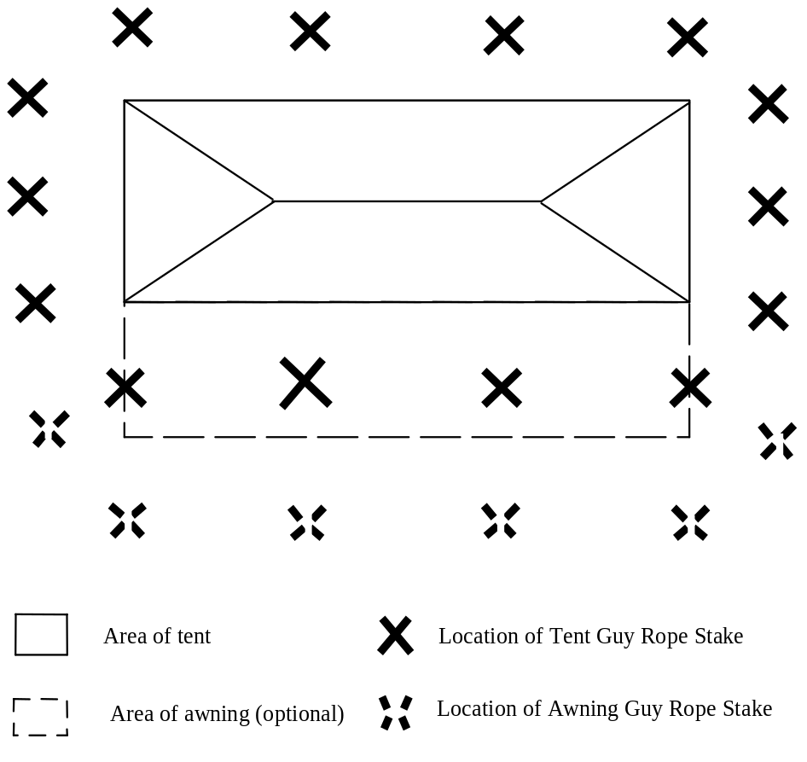
- Look at the way the ropes sets are assembled. There are two steel rings, one fixed at one end of the rope and the other “floating” and free to slide along in the loop formed by the rope slide. It is these rings, and not the ropes, that actually make contact with the stake and the side pole. Functionally, it doesn’t make any difference which ring goes where, but it makes more sense to put the “fixed” ring on the stake and the floating ring on the pin at the top of the side pole. This is because it’s easier to pull downward on the rope to create enough slack to adjust the slider than it is to pull upward So take that fixed ring and slip it onto the head of the stake, and leave the other within reach Repeat with the rest of the stakes you’ve driven.
- Determine which way the wind is blowing. The tent should be set up windward side first. Start with a corner pole, put the pin through the corner grommet, and slip the floating rings of the corner guy-rope over the pin. Now lift the pole up to vertical, using the sliders to adjust the length of the rope as necessary. You can rely on the ropes, and the weight of the unlifted portions of the tent, to keep that pole vertical while you go on to the next corner pole. When all four corner poles are lifted, raise the perimeter poles, first on the long sides, and then the short sides. As you adjust the tension on these ropes, make sure you’re not pulling the roof line outward from the line defined by the corner poles, since that will interfere with the operation of raising the center poles.
- Assemble the banner pole – it comes in two sections, with the smaller aluminum sleeve fitting into the larger one until the catch button in the former sleeve pops into the hole in the latter. Then assemble the ridge pole/center pole assembly by first sliding the ridgepole center sleeve into one of the ridge pole pieces (if it isn't already) and then into the other ridge pole piece. Then swing the center pole upper sections away from the ridgepole and plug them into the center pole lower sections. (Be very careful with the aluminum sections! They are quite strong, but if you put a dent in the center sleeve or in the parts of the ridgepole that it goes into, they won't go together easily.) Slide this assembly under the tent, so that the ridgepole is approximately at the center of the tent. At each end of the ridgepole, you'll find a pulley with a rope bundled in a loose knot. The rope has a snap hook at each end. Untie the bundle (but not the knots holding the snap hooks). Clip one of the hooks onto the eye-screw in the end of the banner pole and the other onto the eye screw in the center pole. Repeat with the rope at the other end of the ridgepole. At each end of the ridgepole, there’s also a short pin sticking up. Slide this pin through the grommet in the top of the tent.
- Locate the pieces of rope sewn onto the inside of the ridge, and tie the ridgepole to the ridge fabric. (This step is important! It keeps the tent planted on the ridge pole pins when the wind gets strong and, when the tent is being taken down, it also prevents the ridgepole from coming apart and braining whoever is underneath it.) Once the ridgepole is firmly attached to the fabric, you may raise the center poles to the vertical position.
- Adjust all the ropes to remove the wrinkles from the roof, and make sure that they are all tight.
- Hang the wall segments for the short ends (they are larger than the other sidewall panels, have green-colored mitered corners (in other words, they're not square), and lack the small panel with the Arms of the West that you’ll find on the long-side segments). The reinforcement patches should be on the inside of the tent, and the stake loops outside. If you are short, you’ll find it helpful to temporarily lower the pole to the point where you can reach the D-rings.
- Hang the rest of the wall segments on the long side, two to a side. The front wall and rear wall are identical, each formed of a left side and a right side. How do you tell them apart? Well, for one thing, each section has a small shield-shaped panel at one end showing the Arms of the West. If the sections are hung correctly, these panels will be in the center of the tent, not near the green-colored corners, and they will be facing outward, toward the populace. Think “The West is at the center, and the West faces outward” and you’ll have it right. For another thing, the left and right sides are designed to overlap at the center, with toggles and loops appropriately positioned . If the toggles won’t mate with the loops (or, if at the corners, there’s all toggles and no loops), something’s wrong.
- Stake down the bottoms of all the sidewalls with the 12" tent stakes, starting with the mitered corners. The bottom of the sidewall should be out two feet from the corner and perimeter poles, go give the tent greater ability to withstand winds. Unless the weather is really foul, it shouldn’t be necessary to put in all these stakes. Every other one will do just fine. Now you can attach the sides together with the loops and toggles, leaving doorways where convenient for access and air circulation.
- To hang the awning, simply attach the long end to the face of the pavilion using the snap hooks on the awning and the D-rings sewn onto the valance at the front of the tent.. Using the diagram on the previous page, you can figure out where the awning stakes and ropes go. Note that if you’re trying to attach a D-ring to a D-ring, you’ve got the awning backwards. The reason that there are D-rings in the awning is so that a second awning can be attached to the first, using the remaining ropes, poles, and stakes. (Don’t omit these extra poles and try to support the double awning with only four poles. The awning will sag horribly in dead air and flutter uncontrollably in a gust of wind.)
In fact, there is a lot of flexibility in how to set up the awning. One awning is ten feet deep, giving you 280 square feet of shade. The other awning is fifteen feet deep, providing 420 square feet. Both together give you 700 square feet of shade. And if you need an awning of truly monstrous proportions, you can borrow four more poles, six ropes, and six stakes and press the front wall into service as an additional extension (with the two halves connected at the center, of course.) This will yield about 930 square feet of shaded area.
Of course, this is only practical when there is there is dead calm air. In anything more than a gentle breeze, you will find yourself limited to only the two awning panels, and if the wind is stiff, even one awning panel will be a handful. Remember that this awning is not as aerodynamically stable as a sunshade of the same dimensions.

Taking Down

Taking down is the reverse of the above. The sidewall panels need not be separated, but transport might be easier if they were.
It’s wise to loosely coil the ropes individually, knotting the coil with an overhand knot to keep it untangled. Same for the rope that holds the banner pole.

Maintenance

The royal pavilion’s fabric should need no maintenance except for occasional washing. Wash with a mild detergent solution (the type of detergent used for hand-washing dishes is best), using a soft brush on the dirtiest areas if necessary. Be careful not to scrub off the artwork! Follow the washing with a very thorough rinsing, to get every trace of the detergent off. (Protracted exposure to the combination of detergent, moisture and sunlight is extremely damaging to the cloth.).
Occasionally spray the ridge pole sleeve with silicone spray to keep it slippery. Swabbing it (and the insides of the ridge-pole sections) with boiled linseed oil once a year or so will help preserve the aluminum from corrosion.
The poles should be give a light coat of paste wax when needed. When the finish on the poles deteriorates, they should be completely stripped of their finish and a new finish applied, preferably a high quality polyurethane or “spar varnish” optimized for outdoor use. The poles were originally finished with a Sikkens “Cetol” treatment which varnish cannot stick to.

- Revised August 28, 2006 by Johann von Drachenfels (John LaTorre)

